4.8 part a

**Code:**

%Exercise 4.8

%Part a

M=10000;

K=100;

N=30;

T=(M-K)/N;

mu=2;

lambda=1;

rho=lambda/mu;

n1=0;

nn1=n1;

ev_list=inf*ones(2,2);

t=0;

tot=0;

tt=0;

ev_list(1,:) = [-log(rand)/lambda, 1];

N_ev=1;

Tot = zeros(1, N);

while t < M

t = ev_list(1,1);

tt=[tt,t];

ev_type = ev_list(1,2);

switch ev_type

case 1

    interarrival

    case 2

        service

end

N_ev = N_ev - 1;

ev_list(1,:) = [inf,inf];

ev_list = sortrows(ev_list, 1);

nn1 = [nn1, n1];

tot = tot + nn1(end-1)*(tt(end) - tt(end-1));

end

batches = zeros(1,N);

D = zeros(1,N);

for i = 1:N

    batches(i)=mean(nn1(101 + (i-1)*T:100 + T*i));

end

batchmean = mean(batches);

re = std(batches)/hope/sqrt(N)

res= tot/t;

fprintf('batches %g ; 0.95 CI (%g, %g) /n', batchmean, batchmean*(1-1.96*re), batchmean*(1+1.96*re))

**Definitions:**

%interarrival.m

N_ev = N_ev + 1;

ev_list(N_ev, :) = [t - log(rand)/lambda, 1];

if n1 == 0

    N_ev = N_ev + 1;

    ev_list(N_ev, :) = [t - log(rand)/mu, 2];

end

n1 = n1+1;

% service.m

n1=n1-1;

if n1 ~= 0

N_ev = N_ev + 1;

ev_list(N_ev,:)=[t - log(rand)/mu, 2] ;

end

**Output:**

>> hw8prob8crap

re =

0.0362

batches 1.01037 ; 0.95 CI (0.93872, 1.08202) /n>>

**4.8 part b**

**Code**

%Part B

M=10000;

K=100;

N=30;

T=(M-K)/N;

mu=2;

lambda=1;

rho=lambda/mu;

n1=0;

nn1=n1;

ev_list=inf*ones(2,2);

t=0;

tot=0;

tt=0;

ev_list(1,:) = [-log(rand)/lambda, 1];

N_ev=1;

R = zeros(1,N);

tau = zeros(1,N);

Rsum = 0;

regcount = 0;

lastregtime = 1;

for i = 1:numel(nn1)

while t < M

t = ev_list(1,1);

tt=[tt,t];

ev_type = ev_list(1,2);

switch ev_type

case 1

    interarrival

    case 2

        service

end

Rsum = Rsum + nn1(i);

N_ev = N_ev - 1;

ev_list(1,:) = [inf,inf];

ev_list = sortrows(ev_list, 1);

nn1 = [nn1, n1];

end

if nn1(i) == 0

    regcount = regcount + 1;

    R(regcount) = Rsum;

    tau(regcount) = i - lastregtime;

    Rsum = 0;

    lastregtime = i;

end

end

regmean = mean(R)/mean(tau)

Covariance = cov(R, tau);

S = sqrt(Covariance(1,1)-2*regmean*Covariance(1,2) + regmean^2*Covariance(2,2))

RelError = S/mean(tau)/sqrt(M)

fprintf('regmean %g; 0.95 CI (%g, %g) \n', regmean, regmean*(1-1.96*RelError), regmean*(1+1.96*RelError))

**Output:**

>> hw8prob8b

RelError =

0.0589

regmean 1.06699; 0.95 CI (0.943813, 1.19016)

**Part C**

Relative Width = 1.96 x 2 x Relative Error

For part a and part b, the relative width around the confidence intervals are 0.1176 for part a and 0.2309 for part b, this is for simulation time of M = 10,000. If we increase M to 70,000 we see that the relative error shrinks down to approximately 0.0145 for part a and if we increase to 170,000 for part b, we get an approximately relative error of 0.0145 as well. This gives a relative width of approximately 0.05 for each.

The output for each is below. Note: the code is not attached for this because it is exactly the same as the above just with M = 70,000 for part a and M = 170,000 for part b. (Note, I know the solution manual says 60,000 for both, but that did not work for my code).

Output for part a:

re =

0.0145

batches 0.992564 ; 0.95 CI (0.964332, 1.0208) /n>> hw8prob8b

Output for part b:

RelError =

0.0145

regmean 0.989388; 0.95 CI (0.961363, 1.01741)

**Exercise B**

1. np.random.seed(123)

sample.size = 5000

numpoints = 25

d = np.random.uniform(0,1,(numpoints, sample.size))

dbar = np.sort(np.mean(d,0))

ugen = np.random.uniform(0,1,sample.size)

unorm = sample.size*ugen

unorm = unorm.astype(int)

dbarbar = np.sort(dbar[unorm])

plt.hist(dbarbar, bins = np.linspace(0,1,100))

plt.show()

**Output:**

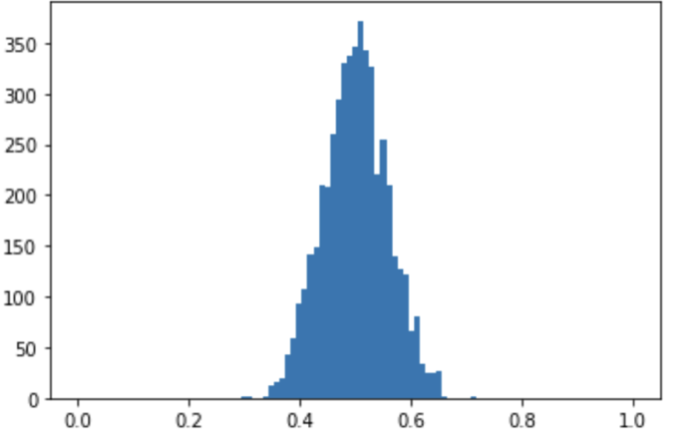

**b**

updatedbar = np.mean(dbar)

L = int(0.025*sample.size) – 1

U = int(0.975*sample.size) – 1

Lb = dbar[L] – updatedbar

Ub = dbar[U] – updatedbar

print(“CI “str(Lb)” “+str(Ub)+’)

Output:

(-0.137899983311, 0.140012210078)